Employer: Auckland University of Technology - Human Potential Centre
Employer Address: 17 Antares Place, Rosedale, Auckland 0632

Dates of Work: 1 May 2023 - 6 August 2025
Total Hours: 400
Date of Report: Monday, 11 August 2025

Jackson Schofield
Software Engineering
Department of Electrical, Computer and Software Engineering

SUMMARY
Auckland University of Technology (AUT) is a major New Zealand university with a strong applied-research focus. I was based at the Human Potential Centre (HPC) within AUT Millennium, serving as the sole software engineer for the Human Interference Scoring System (HISS) project.
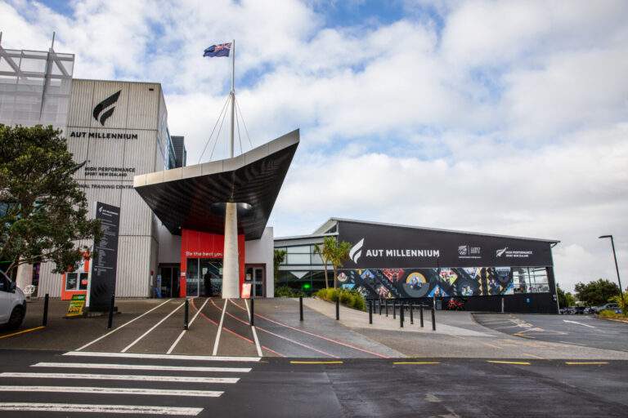
HISS helps users assess diet quality by classifying foods into three groups: unprocessed/minimally processed, processed, and ultra-processed. I delivered the full technical implementation-from a blank codebase to production-ready iOS and Android builds suitable for research participants.
The stack comprised Flutter (Dart), Firebase Authentication, Firestore, and Cloud Functions. I evaluated several computer-vision options, initially integrating LogMeal and later standardising on OpenAI vision models as accuracy and structured output improved. I redesigned data access for speed and reliability, moved logic into Cloud Functions, and optimised image handling and parsing for responsive user experience. See architecture diagram below
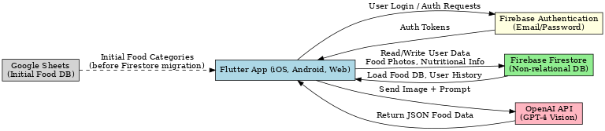
Beyond coding, I translated research goals into actionable requirements, ran TestFlight and Android distributions for trials, coordinated feedback, and iterated UI/UX based on focus groups. Key learnings included communicating trade-offs to non-technical stakeholders, planning architecture before implementation, and building maintainable, modular components.
Outcomes included a stable cross-platform research app, positive participant feedback regarding healthy eating awareness, and contribution to two peer-reviewed papers. The project continues to support PhD-level research and exploration of a broader release.

ACKNOWLEDGEMENTS
I would like to thank Associate Professor Caryn Zinn, Jess Campbell, and Jacqui Pratt for guidance, review, and sustained collaboration. I am also grateful to the wider HPC and AUT team and to study participants and focus-group members whose feedback directly shaped the product.

TABLE OF CONTENTS
Summary ……………………………………………….. [ 2 ]
Acknowledgements ………………………………………. [ 3 ]
Introduction ……………………………………….. [ 5 ]
Company Information ………………………………….. [ 5 ]
Work Experience ……………………………………… [ 6 ]
Reflective Appraisal …………………………………. [ 11 ]
Conclusions …………………………………………. [ 12 ]

INTRODUCTION
This report outlines my practical work experience as a Research Assistant and Software Engineer at AUT’s Human Potential Centre. My role was to design, build, and deploy the Human Interference Scoring System (HISS) as a cross-platform mobile application enabling diet-quality assessment via image classification. The report covers organisational context, work undertaken, technical decisions and outcomes, and a reflective appraisal of skills developed and lessons learned.

COMPANY INFORMATION
2.1 Organisation Overview
AUT is one of New Zealand’s largest universities with a strong culture of applied research and industry collaboration. I was based at the Human Potential Centre (HPC), part of the Sports Performance Research Institute of New Zealand (SPRINZ) at AUT Millennium.
2.2 Workplace Layout and Facilities
HPC operates within AUT Millennium, with offices and meeting spaces adjacent to research and testing facilities. Day-to-day work combined on-site collaboration and remote development. All software services were cloud-hosted; mobile builds were produced on my development machine.
2.3 Staff Structure
HPC typically includes 10–15 researchers and postgraduate students working across nutrition, exercise science, mental health, workplace wellbeing, and chronic disease prevention. The HISS project team comprised a research lead (A/Prof Zinn), research assistants, and me as the technical lead.
2.4 Technical Facilities and Amenities
The project leveraged AUT’s Apple Developer account, secure cloud infrastructure (Firebase/Google Cloud), and standard collaboration tooling. No AUT-owned hardware was required for the app’s development or deployment.

WORK EXPERIENCE
3.1 Project Overview
HISS classifies foods into three groups (unprocessed/minimally processed; processed; ultra-processed) using AI vision on meal photos. I was engaged to transform a research concept and spreadsheet categorisation into a robust cross-platform application capable of supporting trials and future scale.

3.2 Platform and Architecture Decisions
Framework & Language: Flutter (Dart) for iOS/Android (future web build available).
Backend: Firebase Authentication, Firestore (data), Cloud Functions (server logic), Firebase Hosting (where suitable).
Dev Environment: macOS, VS Code, iOS Simulator and Android Studio for platform builds.
Source Control: GitHub with feature branches and protected main for releases.
Distribution: TestFlight (iOS) and Firebase App Distribution (Android).
Rationale: Flutter’s single widget system and performance suit consistent UI across platforms; Firebase provides rapid, secure auth and data services with minimal ops overhead.
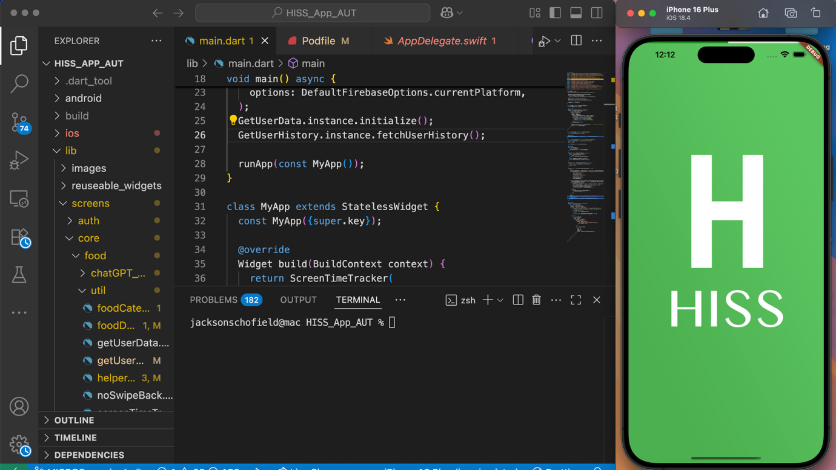
3.3 AI Model Integration
Initial Approach: LogMeal API for food recognition.
Migration: Evaluation of newer vision models (including Claude Vision) led to adopting OpenAI for improved accuracy, latency, and schema-friendly output.
Prompting & Parsing: Iterative prompt engineering and schema hints enabled reliable structured JSON extraction (HISS category, food list, confidence/context). Dart parsers were hardened for resilience and speed.
3.4 Data Architecture and Performance
- Early prototypes queried a 3,000+ item Google Sheet, causing >10 s startup. I:
- Consolidated items into rule-based categories to reduce payloads.
- Migrated rules to Firestore, with Cloud Functions handling compute-heavy logic.
- Optimised image processing (resolution limits, base64 compression).
- Applied async/background isolates in Flutter to keep UI responsive.

Firestore Structure
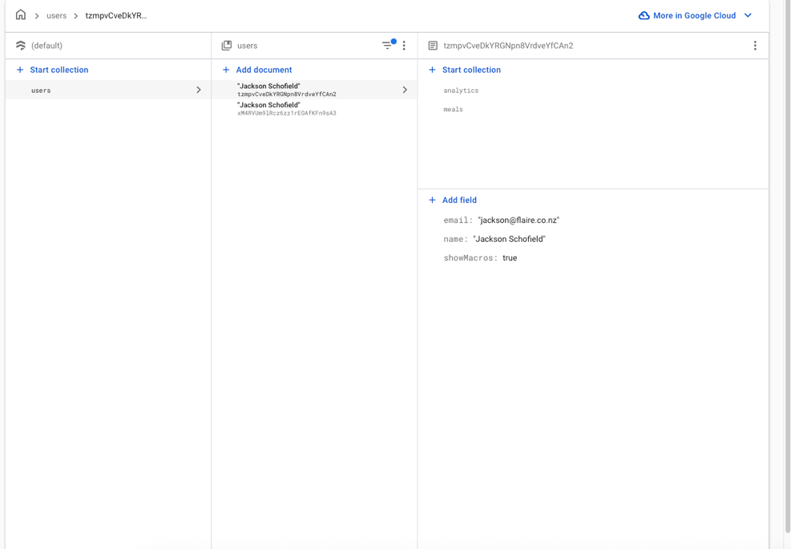
3.5 UI/UX and Feature Set
- Camera/gallery capture and secure sign-in (email/password, reset).
- Meal history with images and per-day HISS proportions.
- Results dashboard (daily/weekly), informed by focus-group feedback.
- Designs iterated with researchers; accessibility and latency were prioritised.
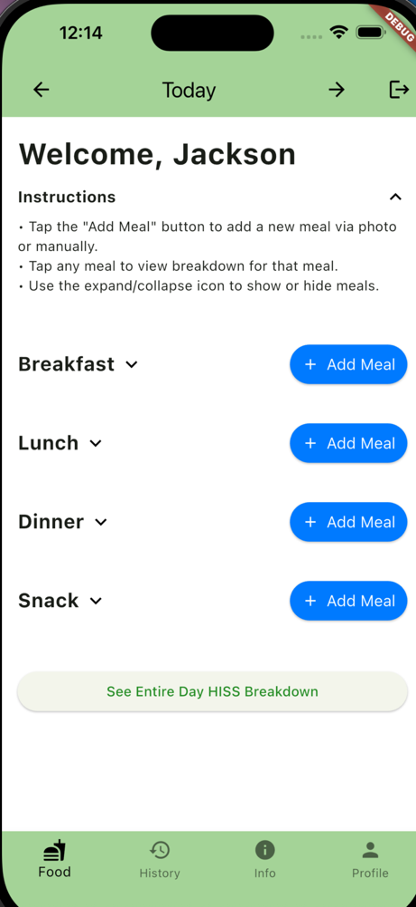

3.6 Development & Testing Workflow
- Requirements captured as acceptance criteria; regular sessions with A/Prof Zinn and RAs.
- Signed iOS archives to TestFlight; Android via Firebase App Distribution.
- Cohort onboarding using public TestFlight links as appropriate.
- Hot-fixes for blocking issues during trials; batching of non-critical items post-session.
3.7 Collaboration and Communication
I translated technical constraints (e.g., inference latency, platform differences) into clear options and trade-offs for non-technical colleagues. I also explored potential custom model approaches with external university engineers from UC. Implementation remained my responsibility.

3.8 Key Challenges and Solutions
- Multi-platform deployment: Provisioning, privacy declarations, SDK/library issues resolved via platform-specific build pipelines and dependency pinning.
- Reliable structured output from LLMs: Achieved via schema-constrained prompting, strict parsers, and graceful fallbacks.
- Responsiveness under network load: Image/response optimisation, Cloud Functions offload, and Flutter async patterns.
3.9 Outcomes and Impact
- Stable cross-platform research app used in trials.
- Participant feedback indicated improved awareness of ultra-processed food intake.
- Two peer-reviewed publications; ongoing PhD research uses HISS.
- Codebase and cloud architecture positioned for further trials and eventual scale.
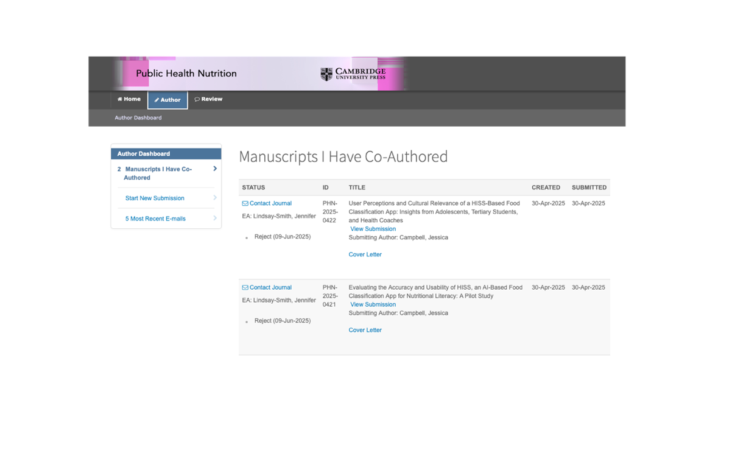
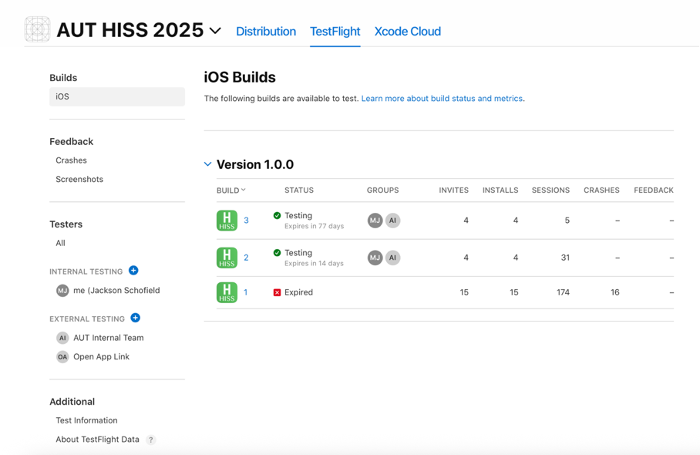

REFLECTIVE APPRAISAL
Working within HPC provided an ideal environment to develop both technical and professional capabilities. The culture was supportive and collaborative, with autonomy balanced by clear research goals. While limited day-to-day management occasionally created ambiguity, it prompted me to take ownership of clarifying requirements and to seek early feedback. This experience strengthened my ability to work independently while still aligning with the team’s overarching objectives, a skill that will be valuable in any professional engineering context.
Technical Growth. I progressed from prototyping to designing and shipping production-quality software. This included first-principles architecture planning, strong use of Flutter/Dart, and integration of Firebase for authentication, data, and serverless functions. Implementing computer-vision inference in a user-facing context required disciplined prompt design, robust parsing, and attention to latency and failure modes. I also built a small library of reusable Flutter widgets to enforce consistent styling and enable rapid UI changes through centralised components.
Beyond this, I developed deeper expertise in deployment pipelines and cross-platform considerations, learning how to manage provisioning profiles, App Store/TestFlight requirements, and Android distribution through Firebase App Distribution. Handling differences in camera libraries, permission systems, and image processing between iOS and Android improved my ability to anticipate platform-specific challenges. I also gained practical experience in performance profiling, identifying bottlenecks in both the client and backend, and making informed trade-offs between speed, accuracy, and maintainability.
Professional Skills. I learned to communicate complex technical ideas in accessible language, framing decisions around user impact, research needs, and constraints such as time, cost, and privacy. I formalised requirements into acceptance criteria and improved documentation so future contributors can extend the system. Iterative UI/UX work with focus groups reinforced the value of user-centred design, particularly when working with diverse participant groups.
This role also sharpened my time management and prioritisation skills. I regularly had to balance long-term architectural improvements with short-term trial deadlines, deciding when to apply quick fixes and when to invest in foundational changes. In doing so, I became better at negotiating scope, managing expectations, and aligning technical roadmaps with research timelines.
Ethics, Safety, and Quality. Handling participant data reinforced secure-by-design principles and the importance of reliability in a research setting. I treated quality assurance as essential to protecting both user experience and data integrity. My approach to testing evolved to include not just functionality, but also data validation, security audits, and fail-safe handling in case of network or API errors. I became more aware of the ethical implications of AI models, especially in health-related contexts, where accuracy and clarity are critical for user trust and safety. This included reviewing AI outputs for potential bias, ensuring they aligned with the intended research purpose, and putting safeguards in place to handle misclassifications.
Personal Reflection. The most challenging tasks involved independently researching unfamiliar areas and presenting clear recommendations. This often meant rapidly learning new frameworks, APIs, or development patterns, then distilling that knowledge into actionable steps for the project. The most rewarding outcomes were tangible research contributions-seeing participants use the app, receiving positive feedback from trial sessions, and co-authoring two journal papers. These achievements gave me a strong sense of professional fulfilment and validated the quality and impact of my work.
If repeating the placement, I would spend more time on-site to deepen cross-team relationships and gain more exposure to other HPC projects. This would not only broaden my technical experience but also provide richer context for integrating the HISS app into larger research initiatives. Overall, this experience confirmed my preference for full-stack development and end-to-end system architecture, as well as my enjoyment of building tools that have direct, measurable impact in both academic and real-world settings.

CONCLUSIONS
This practical work was pivotal in my development as a software engineer. I designed and delivered a cross-platform application integrated with modern AI services and a scalable backend, while maturing my approach to architecture, documentation, and collaboration.
Key Takeaways
- Plan architecture before coding-maintainability and velocity improve.
- Communicate trade-offs clearly to non-technical stakeholders.
- Build for reliability and user trust, especially where research data is involved.
- I am confident designing, building, and deploying end-to-end systems that make a measurable impact.

